Purwell Primary School
2nd February 2023
P
URWELL
NEW
S
L
E
T
T
E
R
Thought for the week: “I have a dream that my four little children will one day live in a nation where they will not be judged by the colour of their skin, but by the content of their character.” – Martin Luther King, Jr.

Feel Good Week (6th- 10th February 2023)
Next week is Feel Good Week, Mrs Barhey has been planning a week that promotes children and young people’s emotional wellbeing by raising awareness of mental health and showing where support can be accessed within the community.
During this week, children will be taking part in a variety of special activities designed to boost their emotional and mental wellbeing. These include: music and art therapy activities; dance workshops with Mrs Eaves and Miss Cunningham; yoga sessions with Mrs Allen (Felix’s mum) and a musical assembly with performances by Mrs Nichol, Miss Plunkett and Mr McCalman.

World book day – Thursday 2nd March
This year World Book Day will be celebrated on 2nd March. At Purwell we strive to instil a love of reading which can spark the imagination and stimulate curiosity!

Words are powerful and can inspire, so this year, for World Book Day we would love children to come dressed as a noun or adjective! This could be a colour- red, yellow, green; an object- a knight, a princess, a scientist or perhaps you want to be sparkly, brave or energetic! We can’t wait to see where your imagination takes you!

Classes will also be completing some book related activities, sharing stories and each child will also receive a World Book Day voucher to spend on a book.

STEM – Science, Technology, Engineering and Maths
For those of you who follow us on Twitter, we hope you have enjoyed the creations that have been posted on there during their STEM Exploring this week and last. STEM stands for Science, Technology, Engineering and Maths. The children have been presented with a series of challenges where they have worked together to design, produce, and then test their creations within a time frame. Collaborative learning, editing and building has been an essential part of the learning.

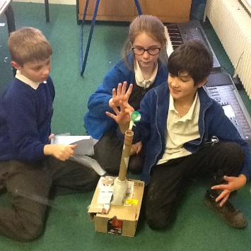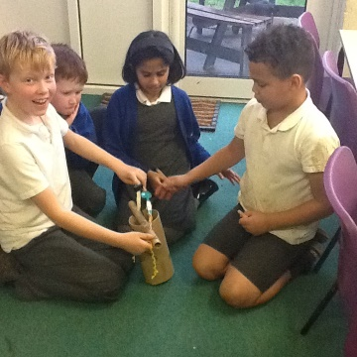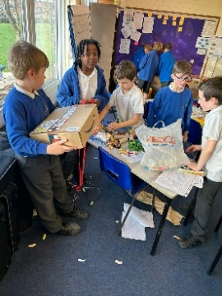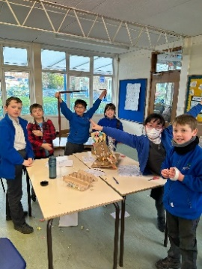

PSA updates
A BIG thank you to the PSA for organising a very enjoyable Quiz Night on Friday evening. Mr. ’Brains’ Brazier hosted the evening and posed questions on a variety of topics and the music round got everyone bopping along. We are very much looking forward to the next one.

BINGO! The next event on the calendar is the Family Bingo Night, which will be held on Saturday 25th March. The tickets will be on sale from Monday 20th March, so look out for those.

We are delighted to announce that the heart defibrillator is now fitted and working. It is located just outside the community room and is ready to save lives if needed. Let’s hope that it is never required.

Clubs for the Spring Term
The majority of clubs running for the Spring term have already commenced with many pupils joining clubs, particularly with the wide offer of lunchtime activities available. Please find below the details of all the clubs that are currently available. For clubs starting after half term a letter will be going out for pupils to join up.
 | LUNCH TIME | AFTER SCHOOL
MONDAY | Board Games/Lego - Yrs 3,4,5,6 | Chess Club - Yrs 3,4,5,6  Cheerleading - yrs 5 & 6 (FULL)
TUESDAY | Year 6 SAT Booster –Invitation only  Girls Football – yrs 4,5,6 | Cycling Club - Yrs 4 & 5  Textile Club - yrs 4, 5,6 (FULL)  Year 6 SAT Booster – Invitation only  Dungeons & Dragons – yrs 4,5,6
WEDNESDAY | Year 6 SAT Booster – Invitation only  Boys Football – yrs 4,5,6 | Glee Club – yrs 5 & 6  Netball – yrs 5 & 6 (FULL)
THURSDAY |  | Cookery club – yrs 3,4,5,6 (FULL)
FRIDAY | Hamma Bead Club – Yrs 3,4,5,6

Support Workshops for Parents and Half-term Activities
With this newsletter you will be sent a list of agencies and workshops that are available to support parents and carers. There will also be a document that details half-term holiday provision and childcare in the local area.

Dates for Spring Term
6th-10th February Feel Good Week
13rd – 17th February Half-term
Thursday 2nd March World Book Day, Non-uniform, dressing up. NEW
Friday 10th March School Closed for Inset Day
Saturday 25th March Family Bingo Night NEW
Wednesday 29th March Parent Consultations
Thursday 30th March Parent Consultations
Friday 31st March Last day of term (2pm finish)

Dates for Summer Term

Monday 17th April School closed for Inset Day
Tuesday 18th April Pupils return to school
Monday 1st May May Bank Holiday
Monday 8th May Coronation Bank Holiday
29th May–2nd June Half-term
Wednesday 28th June Sports Day
Friday 30th June School closed for Inset Day
Friday 21st July Last day of term (2pm finish)

2023 / 2024

Autumn Term 2023
Friday 1st September School closed for INSET day
Monday 4th September Children return to school
23rd – 27th October Half-term
Wednesday 20th December Last day of term

Spring Term 2024
Thursday 4th January Children return to school
19th – 23rd February Half-term
Monday 26th February School closed for INSET day
Thursday 28th March Last day of term

Summer Term 2024
Monday 15th April School closed for INSET day
Tuesday 16th April Children return to school
Monday 6th May Bank holiday
27th – 31st May Half-term
Friday 28th June School closed for INSET day
Friday 19th July Last day of term
Monday 22nd July School closed for INSET day
Tuesday 23rd July School closed for Occasional Day’s holiday

